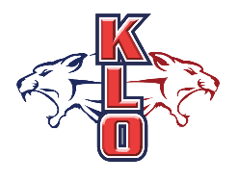
GRADE 8
English
Program
École KLO Middle School
COURSE SELECTION FORM
2018/2019

First name:______________________ Last name: ______________________

REQUIRED COURSES
All Grade 8 students will be enrolled in the following courses:

- English 8
- Social Studies 8
- Mathematics 8
- Science 8
- Physical and Health Education 8
- French 8 (half year)
- Career Education 8 (half year)

EXPLORATORY COURSES
Please choose ONE of the following options:

Fine Arts Exploratory
Grade 8 students will experience one semester of Art and one semester of Drama.

Concert Band
Grade 8 students will experience a FULL year of band.

Concert/Jazz Band
Grade 8 students will experience a FULL year of band.

Please choose from the list below and number your choice in order of preference 1=1st choice / 2=2nd choice / 3=3rd choice / 4=4th choice: Students will receive 2 out of the 4 options.
Home Economics This semestered class is a combination of cooking and sewing.
Tech Ed. This semestered class is a combination of woodwork and computer design.
Choir This semestered class will focus on choir fundamentals and performance.
Community Action Team (CAT) This is a leadership class where students work to make a difference in our school, community, as well as develop a broader world vision.

FORMS DUE BACK ON FEB 14TH IN CORE
Parent/Guardian Signature:
Date:

